2022-2023 SEASON

MINIMUM COACHING REQUIREMENTS
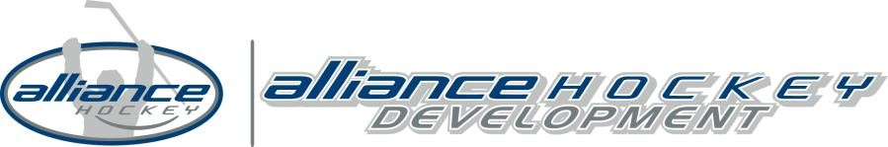
HC = Head Coach AC = Assistant Coach
Division | House League/ House League Select | Minor Development (MD) | Seeded (A/AA) | Pavilion (AAA)
(U7 & Below) Initiation  Program | HC: Coach 1 – Intro to Coach* AC: NCCP is optional
U8 (Minor Novice) U9 (Novice) | HC: Coach 1 – Intro to Coach* AC: NCCP is optional | HC: Coach 1 – Intro to Coach* AC: Coach 1 – Intro to Coach*
U10 (Minor Atom) U11 (Atom) | HC: Coach 2 – Coach Level AC: NCCP is optional | HC: Coach 2 – Coach Level AC: Coach 2 – Coach Level | HC: Coach 2 – Coach Level AC: Coach 2 – Coach Level | HC: Coach 2 – Coach Level AC: Coach 2 – Coach Level
U12 (Minor Peewee) U13 (Peewee) | HC: Coach 2 – Coach Level AC: NCCP is optional | HC: Development 1 Trained AC: Coach 2 – Coach Level | HC: Development 1 Certified AC: Coach 2 – Coach Level | HC: Development 1 Certified AC: Development 1 Trained
U14 (Minor Bantam) U15 (Bantam) | HC: Coach 2 – Coach Level AC: NCCP is optional | HC: Development 1 Trained AC: Coach 2 – Coach Level | HC: Development 1 Certified AC: Coach 2 – Coach Level | HC: High Performance 1 Certified AC: Development 1 Trained
U16 (Minor Midget) U18 (Midget) | HC: Coach 2 – Coach Level AC: NCCP is optional | HC: Development 1 Trained AC: Coach 2 – Coach Level | HC: Development 1 Certified AC: Coach 2 – Coach Level | HC: High Performance 1 Certified AC: Development 1 Trained
U21 (Juvenile) | HC: Coach 2 – Coach Level AC: NCCP is optional

NOTES:
• | *Coaches in divisions U9 (Novice) and below MUST obtain a Coach 1 – Intro to Coach qualification. As per Hockey Canada, NO other qualifications will be accepted.
- All Team Officials (Coach, Trainer & Manager) require Respect in Sport Activity Leader, Gender Identity & Expression Course and HU-Planning a Safe Return to Hockey.
- All A, AA, AAA Coaches require the online Hockey University Checking (HU-Checking) module at U14 (Minor Bantam) & above.
- All qualifications must be registered with ALLIANCE Hockey.
- The “Old NCCP” Intermediate and Level Coach Certifications are acceptable at all levels excluding Head Coaches at U14 (Minor Bantam) to U18 (Midget) AAA and U9 (Novice) & below.
- All Trained Coach 1 – Intro to Coach and Coach 2 – Coach Level Coaches must complete the online Hockey University Modules (HU-Online 1/2) before attending a Clinic.
Upon registration of a Clinic, the Clinic Administrator will provide a participant with a direct link for the Hockey University Modules.
- On-Ice Helpers: Respect in Sport Activity Leader and Gender Identity & Expression Course is recommended
- Refer to the ALLIANCE Hockey Online Manual of Operations for all Team Official requirements (including Trainer).

